MEMORANDUM
To: United States Government Officials
From: Allie Sensinger, Allan Canfield, Bailey Whitaker, Lori Sheets, and Spencer Tuft
Date: March 24, 2026
Subject: Descriptive Patterns in Trust in the Federal Government
This memo analyzes how race, income, and education are descriptively associated with trust in the federal government in the 2024 ANES. This matters because trust shapes how citizens view public institutions, and these patterns help identify which variables deserve the most attention in the later regression analysis.
Trust in government is the dependent variable. It is measured from 1 = Always to 5 = Never, so higher values indicate less trust. Across 5,498 respondents, the mean is 3.56, placing the average respondent between “About half the time” and “Some of the time.” The distribution is concentrated on the low-trust end, with 41.9% answering “Some of the time,” so the outcome is not centered around high trust (see Figure 1).
Race shows the clearest descriptive differences. Mean scores range from 3.32 among Black non-Hispanic respondents to 3.82 among Native American/Other non-Hispanic respondents, a spread of 0.50. Black, Asian/Pacific Islander, and Hispanic respondents report more trust on average than White and multiracial respondents, although the smallest groups should be interpreted cautiously because their sample sizes are limited (see Figure 2).
Income remains important as a comparison variable. Mean trust scores range only from 3.54 to 3.61, a spread of 0.07, so income shows little descriptive variation. Lower-income respondents are slightly less trusting, but the gap is small compared with the racial pattern (see Figure 3).
Education shows a moderate pattern. Respondents with graduate degrees are the most trusting on average (3.41), while those with some college or an associate degree are the least trusting (3.69). The spread is 0.28, which is larger than the income gap but smaller than the racial gap, and it does not follow a simple linear pattern across education levels (see Figure 4).
Overall, trust in government is generally low, but the descriptive evidence suggests that race is more strongly associated with trust than either income or education. That makes race an especially important variable to carry into the regression stage, while income and education remain relevant controls.
Additionally, we analyzed age, state or voter registration, and party as potential control variables. We did not see large variances in state mean trust in government (see Figure 5)
We recommend additional regression analysis to know more certainly the impact these variables have on trust in government.
AI Disclosure: This document was created with assistance from ChatGPT Codex. These AI tools were used for generating and condensing the material in this memorandum. Approximately 40% of this document was reproduced with the help of AI. The content has been reviewed and edited by a human. For more information on the extent and nature of AI usage, please contact the author. A transcript of the AI conversation is attached for further clarity.
https://chatgpt.com/share/e/69b39dd8-cad4-8009-9d2e-c066045a0bc7
Figure 1. Trust in the Federal Government
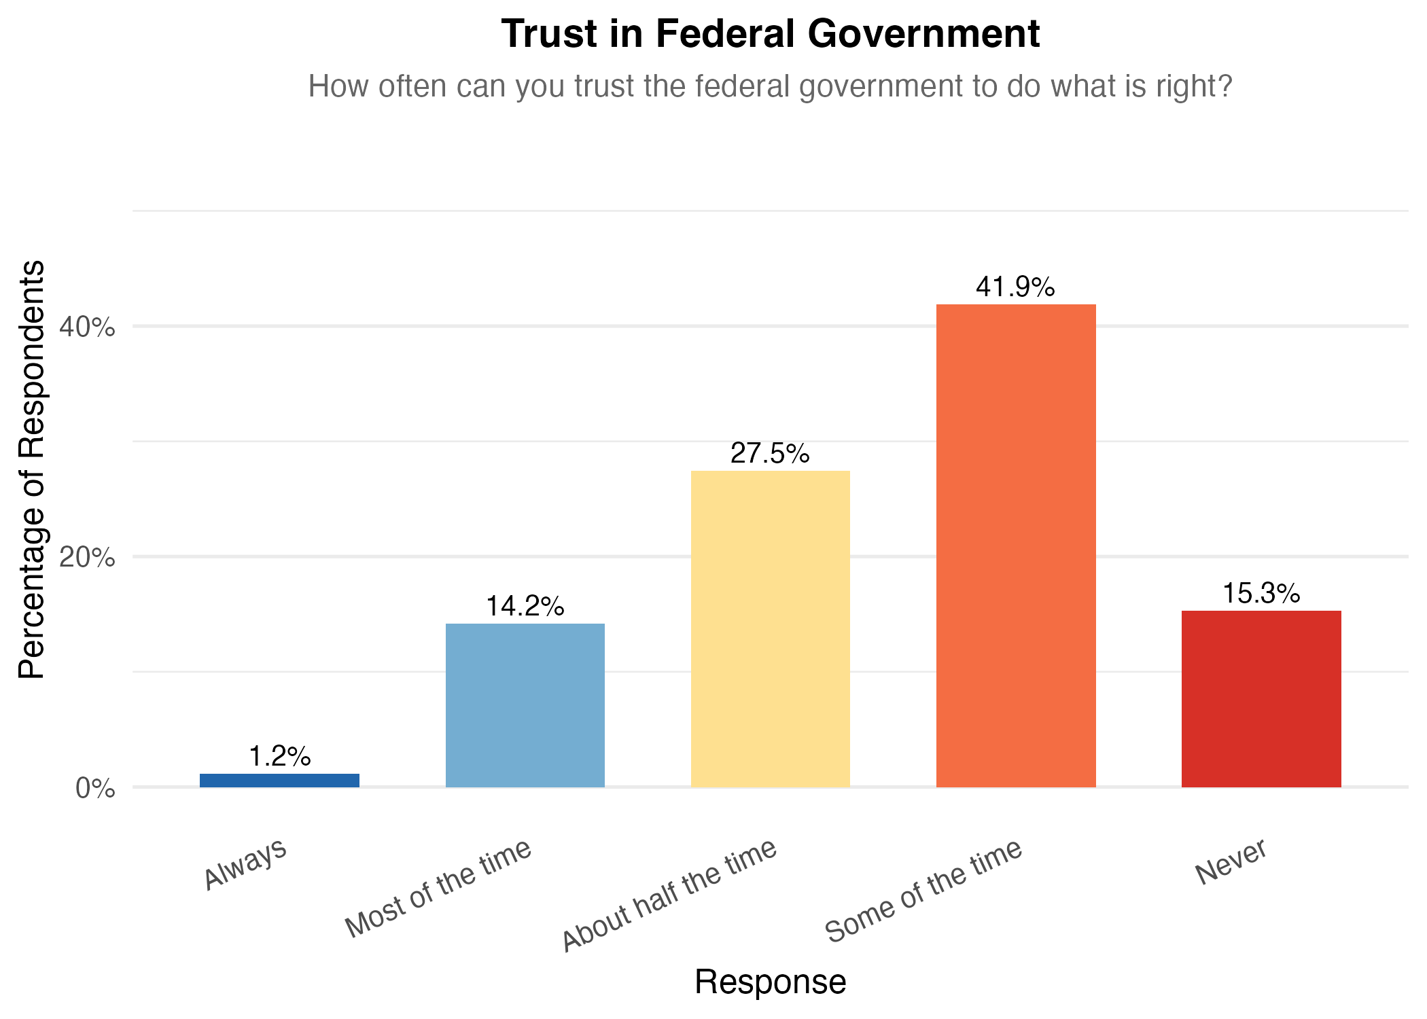
Figure 2. Trust by Race and Ethnicity
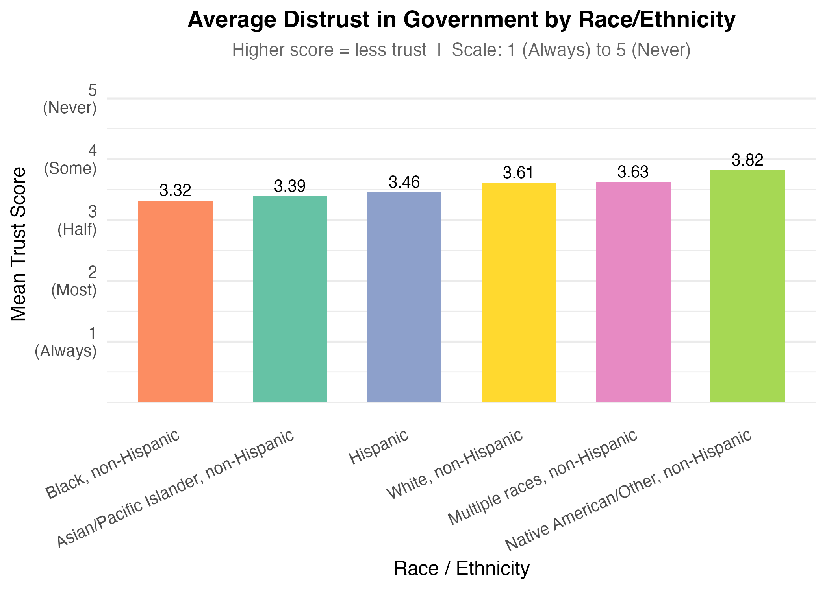
Figure 3. Trust by Household Income
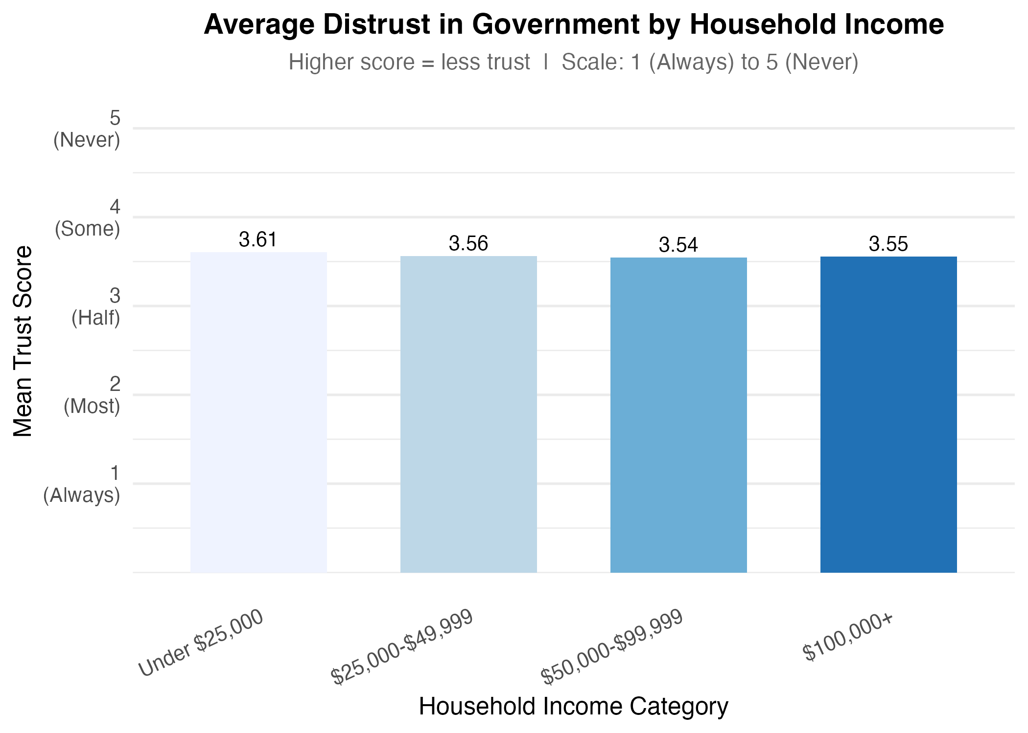

Figure 4. Trust by Educational Attainment
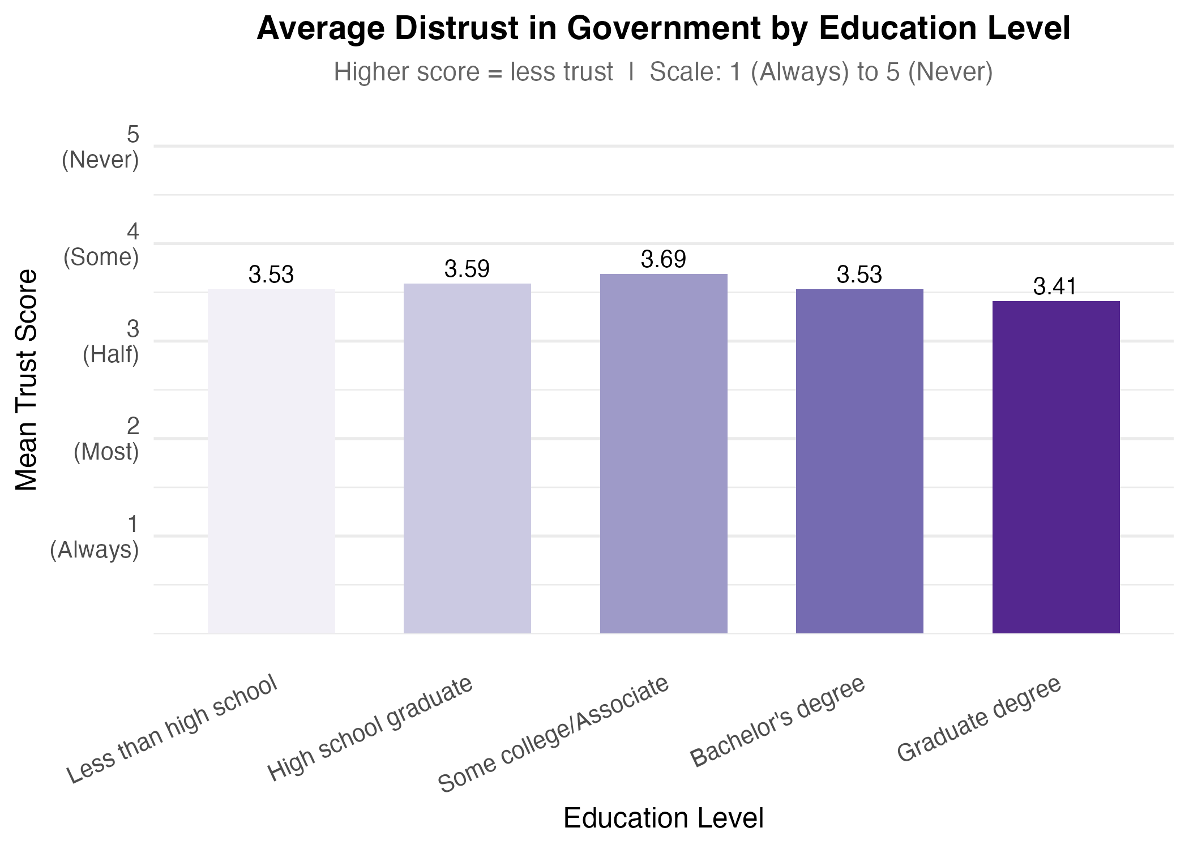
Figure 5. Trust by State of Voter Registration
